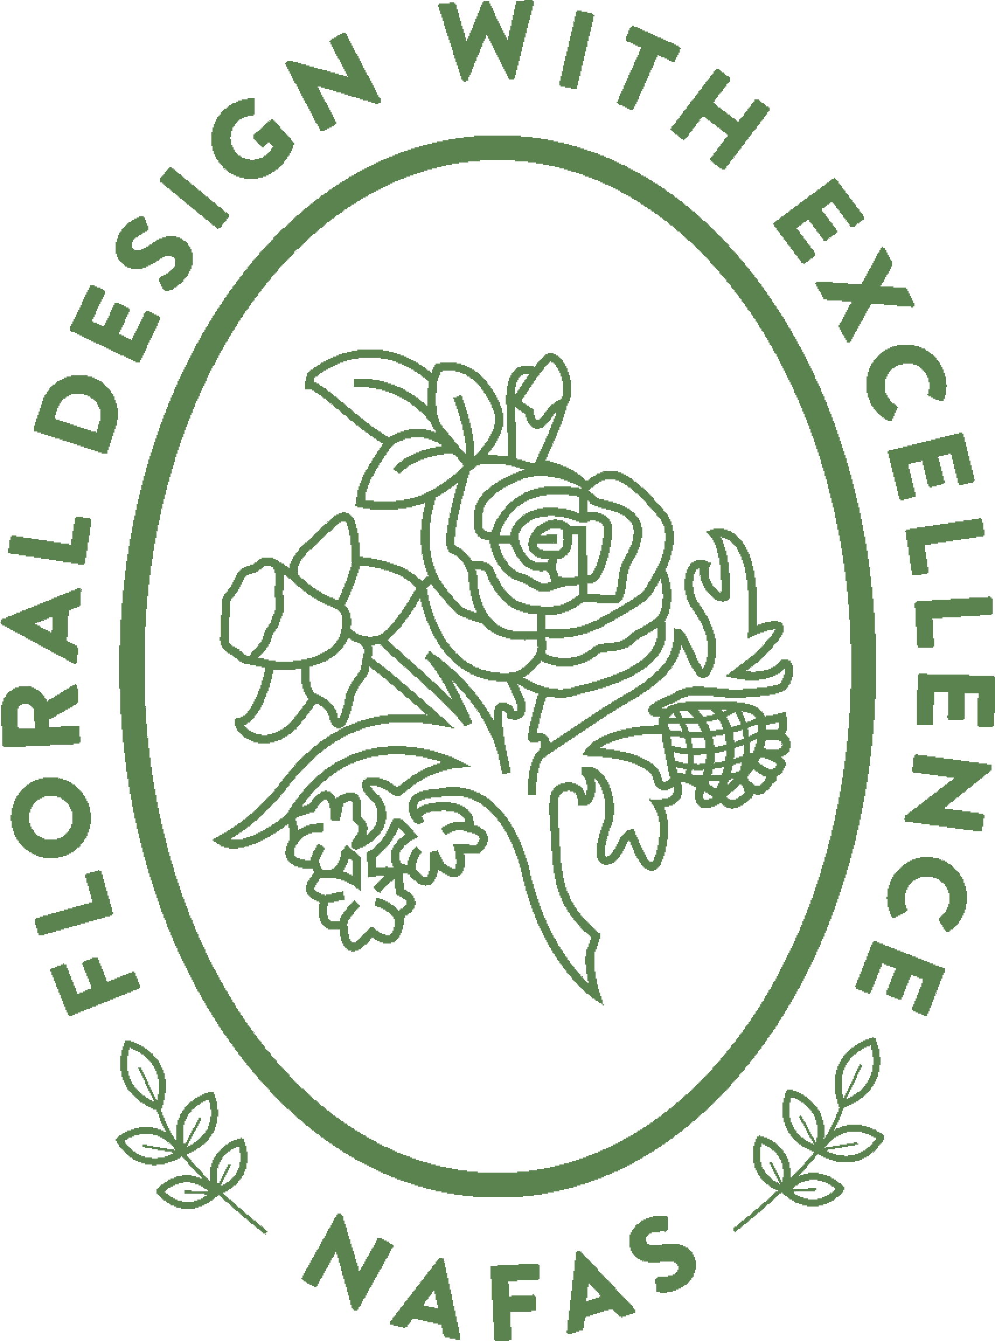
National Association of Flower Arrangement Societies

1st Floor, 42-44 Bishopsgate
London EC2N 4AH

EVENT BOOKING FORM – Judges Residential Symposium 2026
Open to all National and Area Judges

VENUE | Tiverton Hotel, Blundells Road, Tiverton, EX16 4DB
DATE | Friday 9th (arrive from 3pm) to Sunday 11th October 2026 (closes after lunch)

Please complete the areas highlighted in green (where applicable).

NAME
ADDRESS
POSTCODE
EMAIL
TEL / MOBILE No.
NEXT OF KIN DETAILS
Name |  | Relationship | Contact details
AREA
CLUB
 | Please reserve a single ensuite room @ £350.00

DIETARY REQUIREMENTS (y)
 | Vegetarian | Vegan | Gluten Free | Other
Guest 1

PAYMENT OPTIONS - Places will be secured with a completed application form and a deposit of £100 per person. Please note: all costs mentioned above exclude travel. Balance payment by Friday 26th June 2026.

- By BACS to NatWest – NAFAS 2003 - Sort Code 50-00-00 – Account No. 20620926.
Reference – please enter Tiverton followed by your surname and notify lisa@nafas.co.uk advising a transfer has been made.
- By Cheque, payable to NAFAS 2003 and post to Lisa Spencer, NAFAS, 1st Floor, 42-44 Bishopsgate, London EC2N 4AH.
- By Debit / Credit Card, call Head Office on 020 7247 5567.

CANCELLATION POLICY - 50% of delegate fees will be refunded for cancellations received by Friday 29th May 2026. After this, no fees are refundable for cancellation or non-attendance.

DATA PROTECTION – Your privacy is of utmost importance to us; we are committed to maintaining the security and confidentiality of your personal information. If you wish to receive postal, email or phone communication from us please ensure you fill in the corresponding details to ensure we can contact you.

Areas of Interest ✓
Subscribe to the NAFAS Newsletter
Events
The Flower Arranger magazine
Education (JDSE)
New Products

Communication Preferences ✓
Email Communication
Phone Communication
Postal Communication

You are welcome to change your preferences at any time. Please allow at least 10 working days for updates to be made.

Thank you for your booking we are delighted you will be attending Judges Residential Symposium 2026 for which you will receive a receipt. Please send this completed form to lisa@nafas.org.uk or by post to Lisa Spencer, NAFAS, 1st Floor, 42-44 Bishopsgate, London EC2N 4AH.

Any queries please contact Lisa Spencer on 0207 247 5567 or email lisa@nafas.org.uk

